Engineering Ambassadors Tracking System
Software Requirements Specification
CEN 3073 Spring 2018

Modification history:
Version | Date | Who | Comment
v1.0 | 2/13/2018 | Kristin | First draft
v.1.1 | 3/1/2018 | Team | Update software requirements
v1.2 | 3/11/2018 | Kristin | Update introduction

Team Name: EATS (Tuesday 5)
Team Members:
- Chelsea Atkins, cmatkins5902@eagle.fgcu.edu
- Hunter Chagnon, hpchagnon0969@eagle.fgcu.edu
- Daniela Fuenzalida, dafuenzalida1227@eagle.fgcu.edu
- Ritchi Joseph, rgjoseph6465@eagle.fgcu.edu
- Kristin Ladia, knladia6928@eagle.fgcu.edu

Contents of this Document
SECTION 1: Introduction 1
Software to be Produced 1
Applicable Standards 1
Definitions, Acronyms, and Abbreviations 1
SECTION 2: Product Overview 1
Assumptions 1
Stakeholders 1
Use Case Diagram 1
Use Case Descriptions 1
SECTION 3: Specific Requirements 2
3.1 Functional Requirements 2
3.2 Interface Requirements 2
3.3 Physical Environment Requirements 3
3.4 Users and Human Factors Requirements 3
3.5 Data Requirements 3
3.6 Quality Requirements 3
SECTION 4: Additional Material 3

SECTION 1: Introduction

Software to be Produced
The system will be a web-based application accessed by the current Engineering Outreach Specialist to establish and organize meeting times for outreach and ambassador events. Currently, there is no system in place for tracking ambassador hours and pushing event details and times to ambassadors aside from the CANVAS webpage. The new system will establish a way for the current Outreach Coordinator to post events with times, locations, descriptions, and ambassador responsibilities for the event. Current ambassadors can then view and sign up for events using a web-based application. The Outreach Coordinator will be able to log who attended the event and verify the total number of hours the ambassador volunteered. She will be able to access data and statistics regarding these events including maximum event attendance, most popular events, service hours contributed overall and by student, as well as the start and end dates for each student’s served time as an ambassador.

Applicable Standards
- Google Java Style Guide:
  - https://google.github.io/styleguide/javaguide.html
- Oracle Code Conventions for the Java Programming Language:
  - http://www.oracle.com/technetwork/java/codeconvtoc-136057.html *not actively maintained
- Semantic Version Control:
  - http://semver.org/

Definitions, Acronyms, and Abbreviations
- UIN- University Identification Number
- GUI- Graphical User Interface

SECTION 2: Product Overview

Assumptions
- It is assumed that the system will be run from a remove server and that the server will sync every device to keep each instance of the software up to date.

Stakeholders
- College of Engineering
- Engineering Outreach Coordinator
- Engineering Ambassadors
- EATS developers
- Prospective FGCU Students

Use Case Diagram
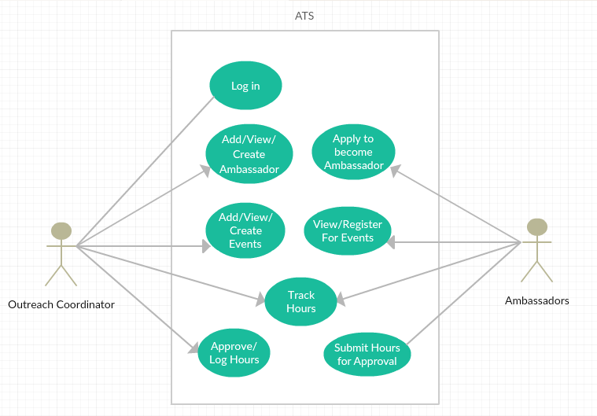

Use Case Descriptions
Use Case: Create Event

Brief Description
This use case scenario explains the steps that would be taken by admin to create and store an event it also demonstrates possible errors that may be encountered.

Actors

Administrators

Preconditions
- Connection to FGCU’s network.
- Past, current, or future event available.
- Admin account.

Basic Flow of Events
- Use Case: Logs in
  - Enter correct admin username and password.
- Click create event option button.
- Fill in form with event details.
  - Set event title.
  - Set event date.
  - Select engineering department.
  - Set event details and important notes.
  - Set event site
- Option to publish or save event as draft.
- Return to main event screen.

Alternative Flows

Incorrect Username or password.
Prompt to verify correct username and password.

Missing required fields if saved and published.
May not be able to save event with missing details.

Failed to publish past event.

Username does not exist.
May need to create profile or verify credentials.

Key Scenarios

No Response from server.
Troubleshoot server issues.

User is not an admin.
Alert that admin account is necessary.

Post-conditions

Successful Completion
Event successfully posted to server; and user returns to the main event screen.

Failure Condition
The logs have been updated accordingly.

Special Requirements
[SpReq:WC-1] Only FGCU students can sign up for event.

Use Case: Add Ambassador

Brief Description
This scenario demonstrates the process of adding the details of a new ambassador; including any errors that may be encountered and possible workarounds.

Actors

Administrators

Preconditions
Student interested in becoming an ambassador.
Student being enrolled must be enrolled at FGCU.
Student being enrolled must be an engineering student.

Basic Flow of Events
- Use Case: Logs in
- Click add ambassador option button.
- Fill in form with student ambassador details.
  - Set ambassador full name.
  - Set ambassador eagle email.
  - Set engineering department for ambassador.
  - Set ambassador’s year and graduating class.
  - Add in ambassador’s bio details.
  - Click submit to store ambassador details.
- Option to add in ambassador hours to a pre-created event or perform Use Case: Create Event
- Return to home screen.

Alternative Flows

Incorrect Username or password.
Prompt to verify and correct username and password.

Missing required fields if attempting to submit.
May not be able to successfully add ambassador.
User will be prompted to address necessary fields.

Username does not exist.
May need to create profile or verify credentials.

Key Scenarios

No Response from server.
6.2 Student being enrolled does not fit one or more of the precondition criteria.

Post-conditions

Successful Completion
Ambassador successfully stored and added to the database.

Failure Condition
The logs have been updated accordingly.
Prompt user error source to address and resolve issues.

Special Requirements
[SpReq:WC-1] Only FGCU students can be an ambassador.
[SpReq2:WC-2] Must be an engineering student.

SECTION 3: Specific Requirements
No: 1
Statement: The system shall have an administrator log in.
Dependency: None

No: 2
Statement: Users shall be able to fill out an application to become ambassadors from the front page of client.
Dependency: None

No: 3
Statement: Administrators shall have the ability to view ambassador applications and create ambassador profile.
Dependency: 2

No: 4
Statement: The system shall output a homepage (dashboard) for administrators which provides quick access to event tools, reporting tools, an agenda, and notifications.
Dependency: 1

No: 5
Statement: Administrators shall have the ability to create new events and specify event details such as date, start and end time, number of required ambassadors, event address, dress code, and a description.
Dependency: None

No: 6
Statement: Administrators shall be able to view an archive of events.
Dependency: 5

No: 7
Statement: Users shall be able to view events through a web-based application and specify whether they can attend events.
Dependency: 5

No: 8
Statement: Administrators shall be able to track ambassador hours by editing existing events.
Dependency: 5, 6

No: 9
Statement: Administrators shall be able to view tracked data.
Dependency: None

No: 10
Statement: Administrators shall be able to specify record parameters such as semester, major, year, day of week, etc. when viewing tracked data.
Dependency: 9

3.1 Functional Requirements
- <Describe the fundamental actions that the software must perform. Functional requirements can be partitioned into subfunctions or subprocesses. Note: the software design partition does not have to correspond with the functional requirements partition.
Functional requirements include:
  - validity checks on the inputs,
  - exact sequence of operations,
  - responses to abnormal situations, including: overflow, communication facilities, and error handling and recovery
  - effect of parameters
  - relationship of outputs to inputs, including: input/output sequences, formulas for input to output conversion
  - ...>

3.2 Interface Requirements
- < Describe the interactions of the software with other entities. Interface requirements include a precise description of the protocol for each interface:
  - what data items are input
  - what data items are output
  - what is the data type, the format, and the possible range of values for each data item? (i.e. what is the "domain" of this data item?)
  - how accurate must each data item be?
  - how often will each data item be received or sent?
  - timing issues (synchronous/asynchronous)>
  - how many will be received or sent in a particular time period?
  - how accurate must the data be?
  - ...>

3.3 Physical Environment Requirements
- < Describe the environment in which the software must run. Physical environment requirements include:
  - type of equipment on which the software must run
  - location of the equipment
  - environmental considerations: temperature, humidity, ...
  - ...>

3.4 Users and Human Factors Requirements
- <Describe the users and their constraints
  - What different types of users must the system support?
  - What is the skill level of each type of user? What type of training and documentation must be provided for each user?
  - Do any users require special accommodations (large font size, ...)
  - ...>

3.5 Data Requirements
- <Describe any data calculations: what formula will be used? to what degree of precision must the calculations be made?
- Describe any retained data requirements: exactly what must be retained?
- Describe any databases that will be used
- ...>

3.6 Quality Requirements
- <Describe quality attributes:
  - What are the requirements for reliability, availability, maintainability, security, portability ...? only address those that pertain to your project
  - How must these quality attributes be demonstrated?
  - Is there a prescribed time the system must be available?
  - Is there a maximum time allowed for restarting the system after a failure?
  - What are the requirements for response times?
  - ...>

SECTION 4: Additional Material
- <Include any additional material e.g. diagrams, photos, etc. as required>

Template created by A. Koufakou based on template from G. Walton http://www.cs.ucf.edu/courses/eel5881/SRSTemplate.html
This page last modified by Kristin Ladia on 2/13/2018

